Installing English Grammar in Use Extra

The installation of English Grammar in Use Extra consists of two separate components:
- the English Grammar in Use Extra content
- the English Grammar in Use Extra application

We strongly recommend that you install these components to the folders suggested during the installation process (default locations).

Windows users
You need to have administrator rights on your computer to complete the installation. On most computers, the installation will start automatically when you place the disc into the CD-ROM drive. If it does not:
1. Open the Start menu and click on My Computer, or double-click on the My Computer icon on the desktop.
2. Double-click on thereall CD-ROM icon.
3. Double-click on the EGUExtra.exe file and follow the onscreen instructions.

Mac users
1. Insert the disc into your CD-ROM drive.
2. Double-click the English Grammar in Use Extra CD-ROM icon on your desktop to open it.
3. Double-click the English Grammar in Use Extra application icon and follow the onscreen instructions.

Installing English Grammar in Use Extra to non-default locations
If you wish to install the English Grammar in Use Extra components to different locations, you must make sure that:
a) you choose a different location for the English Grammar in Use Extra 'application' (the second component installed) from the folder that you chose for the English Grammar in Use Extra 'content' (the first component installed). The English Grammar in Use Extra application folder cannot be located within the English Grammar in Use Extra content folder!
b) you remember where you chose to install English Grammar in Use Extra application and English Grammar in Use Extra content, as you will be asked to navigate to these folders every time you use English Grammar in Use Extra.

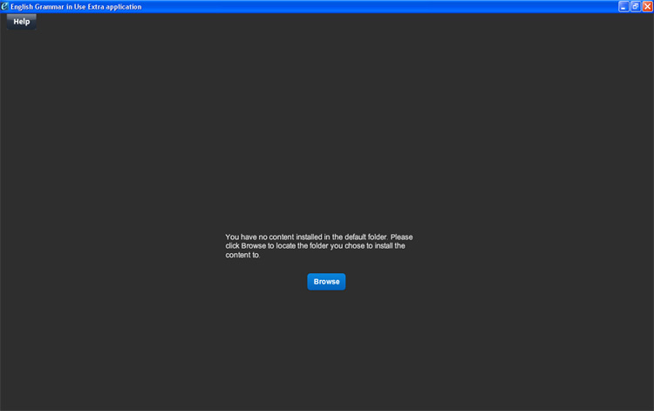

After you have browsed to the content, you will see the following screen:

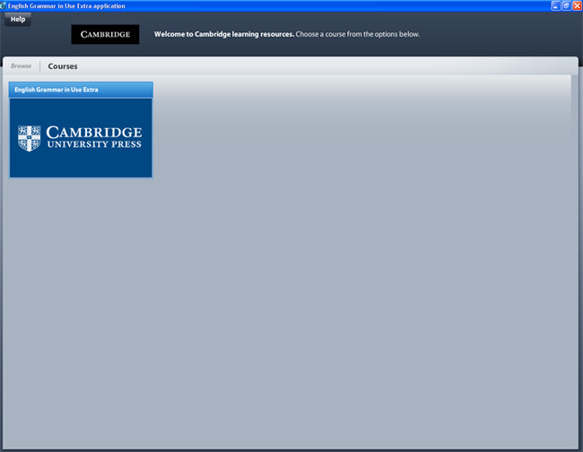

Double click on the course English Grammar in Use Extra. This will lead you to the main menu.

Uninstalling English Grammar in Use Extra from your computer

The installation of English Grammar in Use Extra consists of two parts:
- the English Grammar in Use Extra content
- the English Grammar in Use Extra application

To completely uninstall the English Grammar in Use Extra software, you must uninstall both parts by following the steps below:
Windows users
- Close English Grammar in Use Extra if you are running it.
- From the Start menu, open the Control Panel.
- Double-click Add or Remove Programs (Windows XP) or Programs and then Programs and Features (Windows Vista and 7);
- Find English Grammar in Use Extra application in the products list and click it to highlight it.
- Click Remove (Windows XP) or Uninstall (Windows Vista and 7). The English Grammar in Use Extra application is removed.
- Next, click on English Grammar in Use Extra content to highlight it, click Change/Remove (Windows XP) or Uninstall (Windows Vista and 7) and follow the onscreen instructions.

Mac users
- Close English Grammar in Use Extra if you are running it.
- In your Mac's Applications folder, navigate to the following folder: Cambridge / CambridgeContent / Uninstall_English Grammar in Use Extra content.
- Open the Uninstall_English Grammar in Use Extra content folder, double-click the file called Uninstall English Grammar in Use Extra content, then follow the onscreen instructions.
- Once the uninstallation procedure has finished, go back to the Cambridge folder. In this folder, find the English Grammar in Use Extra application icon. Drag this icon into the Trash to complete the English Grammar in Use Extra uninstallation.

Note: You will need to manually remove the file User instructions from your system if it is no longer needed. The User instructions file is located where the English Grammar in Use Extra content was copied during installation (For example, if you chose the default location, then User instructions will be in C:\Program Files\Cambridge\CambridgeContent).

